**Mini Project**

**(Comparing all neighbor the state of Delhi)**

***Submitted by Golmei Shaheamlung***

**Problem statement**

The Chief Minister of the state (Delhi) wants to have a detailed overview of COVID 19 in the state for the month of June 2020 to plan the strategy for safeguarding the people of the state

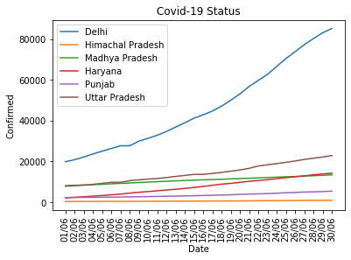

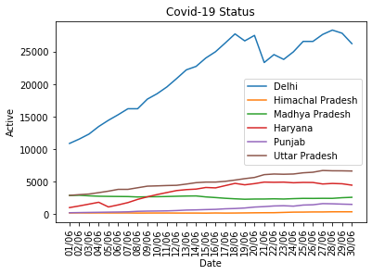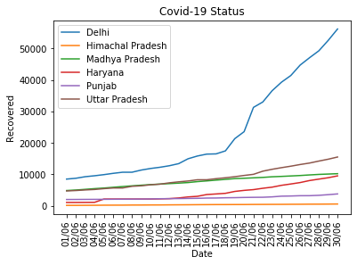

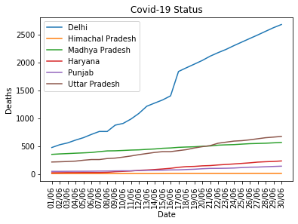

**Code:**

import pandas as pd

data=pd.read_csv('C:/Users/a/Desktop/covid_19_india.csv')

count=data['Sno'].count()

del_date, hp_date, mp_date, har_date, pun_date, up_date = [],[],[],[],[],[]

del_confirmed, hp_confirmed, mp_confirmed, har_confirmed, pun_confirmed, up_confirmed = [],[],[],[],[],[]

del_death, hp_death, mp_death, har_death, pun_death, up_death = [],[],[],[],[],[]

del_cured, hp_cured, mp_cured, har_cured, pun_cured, up_cured = [],[],[],[],[],[]

del_active, hp_active, mp_active, har_active, pun_active, up_active = [],[],[],[],[],[]

for i in range(count):

if data['State/UnionTerritory'][i]=='Delhi':

date=(data['Date'][i])[:5]

if(int(date[3:5])==6):

del_date.append(date)

del_confirmed.append(data['Confirmed'][i])

del_death.append(data['Deaths'][i])

del_cured.append(data['Cured'][i])

del_active.append(data['Confirmed'][i]-data['Cured'][i]-data['Deaths'][i])

elif data['State/UnionTerritory'][i]=='Himachal Pradesh':

date=(data['Date'][i])[:5]

if(int(date[3:5])==6):

hp_date.append(date)

hp_confirmed.append(data['Confirmed'][i])

hp_death.append(data['Deaths'][i])

hp_cured.append(data['Cured'][i])

hp_active.append(data['Confirmed'][i]-data['Cured'][i]-data['Deaths'][i])

elif data['State/UnionTerritory'][i]=='Madhya Pradesh':

date=(data['Date'][i])[:5]

if(int(date[3:5])==6):

mp_date.append(date)

mp_confirmed.append(data['Confirmed'][i])

mp_death.append(data['Deaths'][i])

mp_cured.append(data['Cured'][i])

mp_active.append(data['Confirmed'][i]-data['Cured'][i]-data['Deaths'][i])

elif data['State/UnionTerritory'][i]=='Haryana':

date=(data['Date'][i])[:5]

if(int(date[3:5])==6):

har_date.append(date)

har_confirmed.append(data['Confirmed'][i])

har_death.append(data['Deaths'][i])

har_cured.append(data['Cured'][i])

har_active.append(data['Confirmed'][i]-data['Cured'][i]-data['Deaths'][i])

elif data['State/UnionTerritory'][i]=='Punjab':

date=(data['Date'][i])[:5]

if(int(date[3:5])==6):

pun_date.append(date)

pun_confirmed.append(data['Confirmed'][i])

pun_death.append(data['Deaths'][i])

pun_cured.append(data['Cured'][i])

pun_active.append(data['Confirmed'][i]-data['Cured'][i]-data['Deaths'][i])

elif data['State/UnionTerritory'][i]=='Uttar Pradesh':

date=(data['Date'][i])[:5]

if(int(date[3:5])==6):

up_date.append(date)

up_confirmed.append(data['Confirmed'][i])

up_death.append(data['Deaths'][i])

up_cured.append(data['Cured'][i])

up_active.append(data['Confirmed'][i]-data['Cured'][i]-data['Deaths'][i])

# Import the necessary packages and modules

import matplotlib.pyplot as plt

# Plot the data

plt.plot(del_date, del_confirmed, label='Delhi')

plt.plot(del_date, hp_confirmed, label='Himachal Pradesh')

plt.plot(del_date, mp_confirmed, label='Madhya Pradesh')

plt.plot(del_date, har_confirmed, label='Haryana')

plt.plot(del_date, pun_confirmed, label='Punjab')

plt.plot(del_date, up_confirmed, label='Uttar Pradesh')

# Add a legend

plt.legend()

plt.title('Covid-19 Status')

plt.xlabel('Date')

plt.ylabel('Confirmed')

plt.xticks(rotation=90)

# Show the plot

plt.show()

# Import the necessary packages and modules

import matplotlib.pyplot as plt

# Plot the data

plt.plot(del_date, del_death, label='Delhi')

plt.plot(del_date, hp_death, label='Himachal Pradesh')

plt.plot(del_date, mp_death, label='Madhya Pradesh')

plt.plot(del_date, har_death, label='Haryana')

plt.plot(del_date, pun_death, label='Punjab')

plt.plot(del_date, up_death, label='Uttar Pradesh')

# Add a legend

plt.legend()

plt.title('Covid-19 Status')

plt.xlabel('Date')

plt.ylabel('Deaths')

plt.xticks(rotation=90)

# Show the plot

plt.show()

# Import the necessary packages and modules

import matplotlib.pyplot as plt

# Plot the data

plt.plot(del_date, del_cured, label='Delhi')

plt.plot(del_date, hp_cured, label='Himachal Pradesh')

plt.plot(del_date, mp_cured, label='Madhya Pradesh')

plt.plot(del_date, har_cured, label='Haryana')

plt.plot(del_date, pun_cured, label='Punjab')

plt.plot(del_date, up_cured, label='Uttar Pradesh')

# Add a legend

plt.legend()

plt.title('Covid-19 Status')

plt.xlabel('Date')

plt.ylabel('Recovered')

plt.xticks(rotation=90)

# Show the plot

plt.show()

# Import the necessary packages and modules

import matplotlib.pyplot as plt

# Plot the data

plt.plot(del_date, del_active, label='Delhi')

plt.plot(del_date, hp_active, label='Himachal Pradesh')

plt.plot(del_date, mp_active, label='Madhya Pradesh')

plt.plot(del_date, har_active, label='Haryana')

plt.plot(del_date, pun_active, label='Punjab')

plt.plot(del_date, up_active, label='Uttar Pradesh')

# Add a legend

plt.legend()

plt.title('Covid-19 Status')

plt.xlabel('Date')

plt.ylabel('Active')

plt.xticks(rotation=90)

# Show the plot

plt.show()